1. **LEED Fan Power- Step by Step**

[Bob Fassbender's picture](http://energy-models.com/user/bob-f)

Author: [Bob Fassbender](http://energy-models.com/blog/5)

Posted on: February 10, 2014

**Question:**

USGBC is asking me for a manual calculation on fan power. Can you walk me through how you calculate the fan power for a VAV system for LEED?

**Answer:**

It’s a pretty straightforward process. However, it does require some bouncing around in ASHRAE 90.1 and that can lead to confusion, so after this walk-through you might simply prefer to use our fan calculator. One of the most complicated parts of the calculation is determining the filter credit. But remember that you should only apply the fan credit if ALL the supply air is filtered. (The workaround is discussed in the next segment)

It's best to use an example: Let’s say you have a sound attenuation device on your full supply air of 10,000 cfm and you have a MERV 13 filter on your 2,500 cfm of ventilation air (and only on your ventilation air).

The fan credit (from 90.1 TABLE 6.5.3.1.1B) is .15” for the sound attenuation device and .9” for a MERV 13-15 filter.

From the footnotes of TABLE 6.5.3.1.1a, we see that the credit only applies to the cfm that the air goes through in the filter or device, so the equation for A (in the footnotes) is:

A = sum of (PD× CFMD/4131).

In this case that yields:

A = .9*2500/4131 + .15*10,000/4131 = .908 hp

Then, from Table G3.1.2.9 for variable air volume systems you use:

BHP = CFMs*0.0013 + A

Thus, you have

BHP = .0013*10,000+A = .0013*10,000+.908 = 13.908 bhp

You then have to move to the KW, which is calculated from G3.1.2.9. Since it is VAV, you use the equation for systems 3-8, which is

TOTAL system fan power in watts = bhp*746/efficiency

KW = bhp*746/1000/efficiency = bhp*.746/efficiency

The efficiency comes from the Enclosed Motor at 1800 RPM in Table 10.8. In this case, the efficiency is 91% (selected from the 15 hp row, because G3.1.2.9 specifies that you use the next fan size up, which is 15 hp)

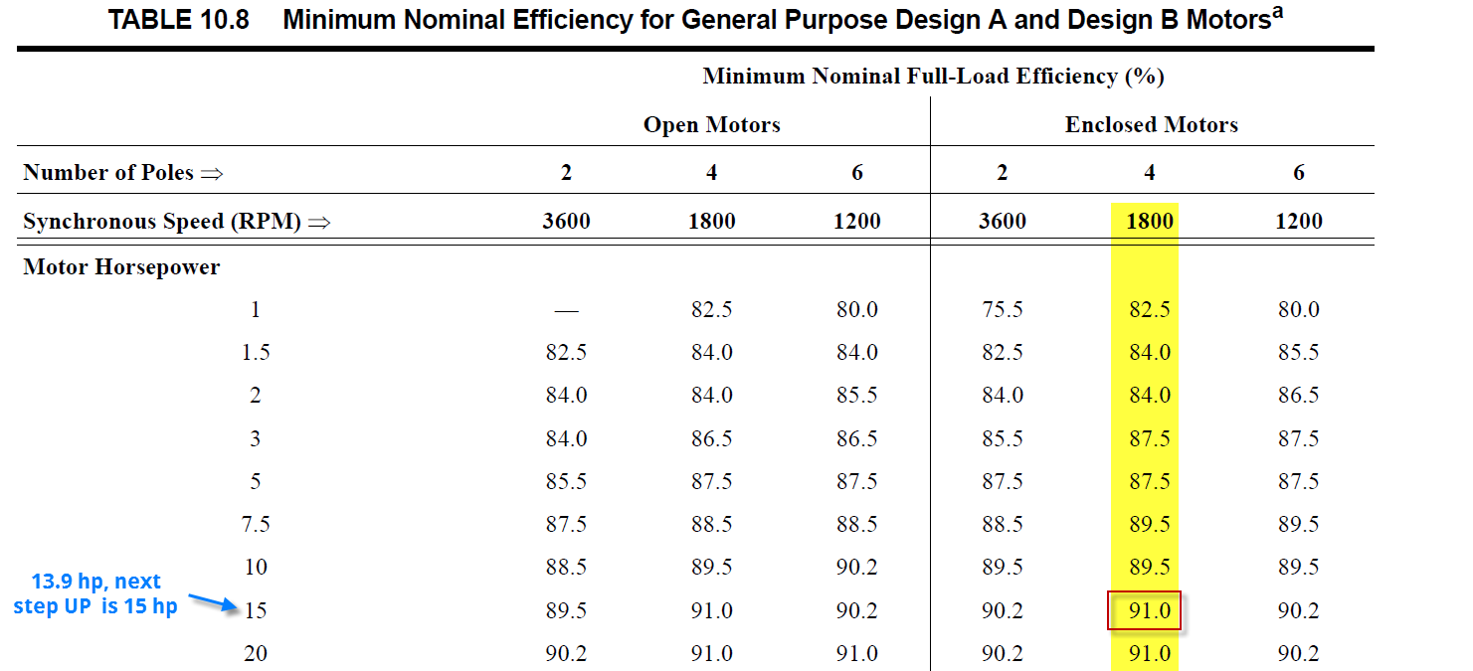

Thus, the total KW = 13.908*.746/.91

= 11.4 KW

**Follow up question:**

So how would I enter this into your fan calculator?

You would need to pro-rate the fan credit.

Fan Credit = (A1*Airflow1 + A2*Airflow2 + A3*Airflow3… + Az*Airflowz)/Total Airflow

In this case, we only have two items, A1 and A2 which yields

(.9*2500 + .15*10000)/10000 = .375

Then, you would enter 10000 cfm into the calculator, a fan credit of .375, select VAV system and click calculate to yield 11.4 KW!